VB.NET PROGRAM TO ADD TWO NUMBERS / INTEGERS
Module
Module1

Sub Main()
Dim x, y, result As Integer

Console.WriteLine(">>> VB>NET Console program to add two integers <<<")
Console.Write(" Enter the first number to be added: ")
x = Convert.ToInt32(Console.ReadLine())
Console.Write(" Enter the second number to be added: ")
y = Convert.ToInt32(Console.ReadLine())
result = x + y
Console.Write(Environment.NewLine & " The sum of two numbers is:" & result)
Console.ReadLine()

End Sub

End Module
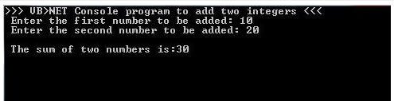

VB.NET PROGRAM TO ADD TWO NUMBERS / INTEGERS USING FUNCTION
Module
Module1

Sub Main()
Dim x, y, result As Integer
Console.WriteLine("*** www.ProgrammingPosts.blogspot.com ***")
Console.WriteLine(">>> VB.NET Console program to add two integers <<<")
Console.Write(" Enter the first number to be added: ")
x = Convert.ToInt32(Console.ReadLine())
Console.Write(" Enter the second number to be added: ")
y = Convert.ToInt32(Console.ReadLine())
result = Sum(x, y)
Console.Write(Environment.NewLine & " The sum of two numbers is:" & result)
Console.ReadLine()
End Sub
Function Sum(ByVal a, ByVal b) As Integer
Dim c As Integer
c = a + b
Return c
End Function

End Module
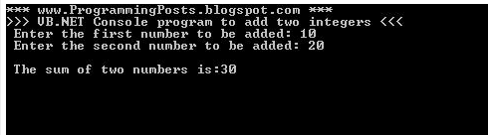

VB.Net Program to get Product of two Numbers
Module Module1

Sub Main()
Dim x, y As Integer
Dim result As Integer
Console.WriteLine("*** www.ProgrammingPosts.blogspot.com ***")
Console.WriteLine(">>> VB.NET PROGRAM FOR PRODUCT OF TWO NUMBERS <<< ")
'vblf gets the cursor to next line in console
Console.Write(vbLf & " Enter the first number : ")
' reading 1st number from user
x = Convert.ToInt32(Console.ReadLine()) 'converting input to type int

Console.Write(vbLf & " Enter the second number: ")
' reading 2nd number from user
y = Convert.ToInt32(Console.ReadLine()) 'converting input to type int

' storing the product in result
result = x * y
'printing the result
Console.WriteLine(vbLf & " The product of two numbers is: {0} ", result)
Console.ReadLine()
End Sub

End Module

Sample Output:
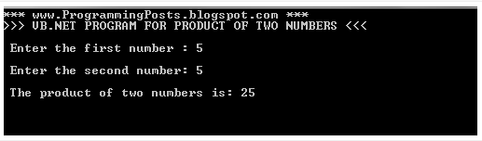

VB.Net Program to Print Sum Of Series 1+2+3+..+n
Module Module1

Sub Main()
Dim sum As Integer = 0, i As Integer, n As Integer
Console.WriteLine("*** www.programmingposts.blogspot.com ***")
Console.WriteLine(vbLf & ">>> VB.Net Program to print Sum of Series 1+2+3+..+n <<<")
Console.Write(vbLf & " Enter the nth number of series: ")
n = Convert.ToInt32(Console.ReadLine()) 'taking input, converting to Int
For i = 1 To n
sum += i 'calculating sum
Next
Console.WriteLine(vbLf & " Sum of series upto {0} is : {1}", n, sum)
Console.ReadLine()
End Sub

End Module

Sample Output:
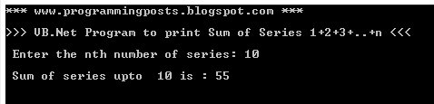

VB.Net Program to Print Reverse of a Number

Module Module1

Sub Main()
Dim num As Integer, remainder As Integer, sum As Integer = 0, rev As Integer
Console.WriteLine("*** www.ProgrammingPosts.blogspot.com ***")
Console.WriteLine(vbLf & " >>> VB.NET Program To Find Reverse Of a Number <<<")
Console.Write(vbLf & " Enter a number: ")
num = Convert.ToInt32(Console.ReadLine())
While Convert.ToBoolean(num)
remainder = num Mod 10
'for getting remainder by dividing with 10
num = num \ 10 ' \ symbol is for Integer Division in vb.net
'for getting quotient by dividing with 10
sum = sum * 10 + remainder
End While
rev = sum
Console.WriteLine(vbLf & " The Reversed Number is: {0} " & vbLf , rev)
Console.ReadLine()
End Sub

End Module

Sample Output:
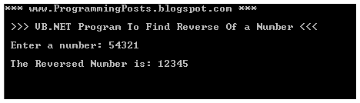

VB.Net Program to find the Number Palindrome or not
Module Module1

Sub Main()
Dim num As Integer, remainder As Integer, sum As Integer = 0, temp As Integer
Console.WriteLine("*** www.ProgrammingPosts.blogspot.com ***")
Console.WriteLine(vbLf & " >>>> To Find a Number is Palindrome or not <<<< ")
Console.Write(vbLf & " Enter a number: ")
num = Convert.ToInt32(Console.ReadLine())
temp = num
While Convert.ToBoolean(num)
remainder = num Mod 10
'for getting remainder by dividing with 10
num = num \ 10
'for getting quotient by dividing with 10
'multiplying the sum with 10 and adding remainder
sum = sum * 10 + remainder
End While
Console.WriteLine(vbLf & " The Reversed Number is: {0} " & vbLf, sum)
If temp = sum Then
'checking whether the reversed number is equal to entered number
Console.WriteLine(vbLf & " The given Number is Palindrome ")
Else
Console.WriteLine(vbLf & " The given Number is not a palindrome ")
End If
Console.ReadLine()
End Sub

End Module

Sample Output:

VB.Net Program to find the Number Palindrome or not
Module Module1

Sub Main()
Dim num As Integer, remainder As Integer, sum As Integer = 0, temp As Integer
Console.WriteLine("*** www.ProgrammingPosts.blogspot.com ***")
Console.WriteLine(vbLf & " >>>> To Find a Number is Palindrome or not <<<< ")
Console.Write(vbLf & " Enter a number: ")
num = Convert.ToInt32(Console.ReadLine())
temp = num
While Convert.ToBoolean(num)
remainder = num Mod 10
'for getting remainder by dividing with 10
num = num \ 10
'for getting quotient by dividing with 10
'multiplying the sum with 10 and adding remainder
sum = sum * 10 + remainder
End While
Console.WriteLine(vbLf & " The Reversed Number is: {0} " & vbLf, sum)
If temp = sum Then
'checking whether the reversed number is equal to entered number
Console.WriteLine(vbLf & " The given Number is Palindrome ")
Else
Console.WriteLine(vbLf & " The given Number is not a palindrome ")
End If
Console.ReadLine()
End Sub

End Module

Sample Output:

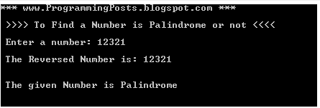

VB.NET Program to get Files Full Path in a given Folder
Imports System.IO

Module Module1

Sub Main()
Try
Dim FolderPath As String
Dim Files As String() 'string array
Console.WriteLine("www.ProgrammingPosts.blogspot.com")
Console.WriteLine(vbLf & ">>>VB.NET PROGRAM To PRINT FULL FILES PATH IN A Given Directory <<<")
Console.WriteLine(vbLf & "Enter the Directory Path to get File Names in it : ")
FolderPath = Console.ReadLine()
Files = Directory.GetFiles(FolderPath)
Console.WriteLine(vbLf & " The FilePaths in given Directory are : " & vbLf & vbLf)
For Each FileName As String In Files
Console.WriteLine(FileName)
Next
Console.ReadLine()
Catch ex As DirectoryNotFoundException 'catching directory not found exception
Console.BackgroundColor = ConsoleColor.Red
Console.WriteLine(vbLf & vbLf & " Directory Not Found..Press any key to exit...")
Console.ReadKey()
Catch ex As Exception 'catching all other exceptions
Console.BackgroundColor = ConsoleColor.Red
Console.WriteLine(vbLf & vbLf & ex.Message)
Console.ReadKey()
End Try
End Sub

End Module

.................
Sample Output :
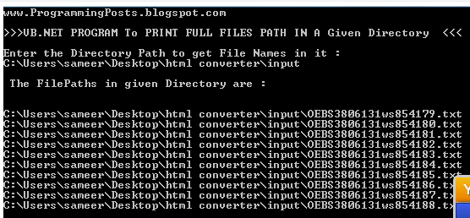

VB.NET Program to get File Names in a given Directory
Imports System.IO
Module Module1

Sub Main()
Try
Dim FolderPath As String
Dim Files As String() 'declaring string array
Console.WriteLine("www.ProgrammingPosts.blogspot.com")
Console.WriteLine(vbLf & ">>>VB.NET PROGRAM To PRINT FILES NAMES IN A Given Directory <<<")
Console.WriteLine(" Enter the Directory Path to get File Names in it : ")
FolderPath = Console.ReadLine()
Files = Directory.GetFiles(FolderPath)
Console.WriteLine(vbLf & " The FileNames with extension in given Directory are : " & vbLf & vbLf)

For Each FileName As String In Files
' Creating the FileInfo object
Dim fi As System.IO.FileInfo = Nothing
Try
fi = New System.IO.FileInfo(FileName)
Catch ex As System.IO.FileNotFoundException
' To inform the user and continue
Console.WriteLine(ex.Message)
Continue For
End Try
' Console.WriteLine("{0}", fi.Directory); //prints filepath
' Console.WriteLine("{0}", fi.DirectoryName); // prints directorypath
Console.WriteLine("{0}", fi.Name)
Next
Console.ReadLine()
Catch ex As DirectoryNotFoundException
Console.BackgroundColor = ConsoleColor.Red
Console.WriteLine(vbLf & vbLf & " Directory Not Found..Press any key to exit...")
Console.ReadKey()
End Try
End Sub

End Module

Sample Output :
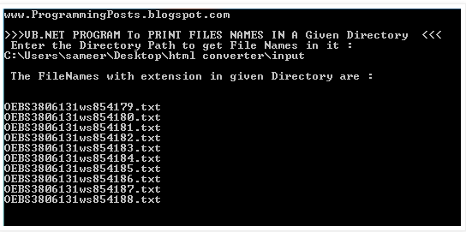

Declaring constants in VB.Net
In this article we will see a small example of using constants in vb.net . constants are declared with a keyword const .
Example :
Const PI As Double = 3.14
Const myStr As String = "*** www.ProgrammingPosts.blogspot.com ***"

The program below is to find the area and perimeter of circle in which we use const .
In the program below we have declared PI as a constant of type double which value is given as 3.14 and
myStr is a const of type string .
It means PI value cannot be changed either at compile time or run-time . If we try to assign the value to constant it gives a complie-time error .
Any Integral or string variables can be declared as constants.
We can also declare constants as public to use it in all the classes in a program.
Module Module1

Sub Main()
'declaring const variable PI
Const PI As Double = 3.14
Const myStr As String = "*** www.ProgrammingPosts.blogspot.com ***"
Console.WriteLine(myStr) 'here myStr is a string constant
Console.WriteLine(">>> VB.NET Program to find Area and Perimeter of Circle <<<" & vbLf)
Console.Write("Enter radius value: ")
Dim r As Integer = Convert.ToInt32(Console.ReadLine()) 'taking radius as input
Dim area As Double = PI * r * r 'getting area of circle
Console.WriteLine("Area of circle is: " & area)

'if we try to assign a value to PI or myStr , we get compile-time error
'PI = 123
'myStr = "this is new string";

Dim perimeter As Double = 2 * PI * r 'getting perimeter of circle
Console.WriteLine("Perimeter of circle: " & perimeter)
Console.Read()
End Sub

End Module
Sample Output :
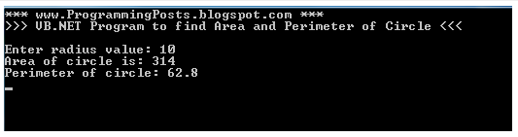

ADO.NET CLASSES

ADO.NET Classes:

Connection:
-> Maintains the connection with the database.

Command:
-> Executes a Query Statement( Select Statement), Non-Query Statement(insert /update/delete) or stored procedure/function at back-end.

DataReader:
->It acts as a buffer, which holds the data, after execution of a query statement at back-end.

DataAdapter:
-> Executes a query statement at back-end.

Parameter:
-> Sends a parameter (argument) value to a back-end stored procedure/function.

Dataset:
->Acts as a buffer which holds multiple tables at a time.

DataTable:
->Acts as a buffer, which holds a single table (collection of rows and columns)

DataRow:
->Acts as a buffer, which holds a single row.

DataColumn:
Acts as a buffer, which holds single column.

Note:
All the above classes needs to create Objects of these classes.

CONNECTING WITH SQL SERVER USING ADO.NET

STEPS WHILE WORKING WITH SQL SERVER :
-> Step 1: Import the library at the top.
using System.Data.SqlClient;
->Step 2: Construct the "Connection" Class object.
SqlConnection con = new SqlConnection();
-> Step 3: Assign the Connection String.
If u are using Windows authentication in Sql Server, then the Connection string will be like this
con.ConnectionString = "Data Source=<Server Name>;Integrated Security=true;Initial Catalog=<Database Name>";
If you are using Sql Server authentication for Sql Server then the connection string is like this.
con.ConnectionString = "Data Source=<Server Name>;user id=<user name of sql server>;password=<password of sql server>;Initial Catalog=<Database Name>";
-> Step 4: Open the connection:
con.Open();
-> Step 5: Construct the "Command" class object:
SqlCommand cmd= new SqlCommand();
-> Step 6: Assign the SQL Statement, which is to be executed:
cmd.CommandText="INSERT / UPDATE / DELETE / SELECT command";
-> Step 7: Assign the reference of connection object, to which the command is to be executed.
cmd.Connection=con;
->Step 8: Execute the Command and receive the number of rows effected.
int n=cmd.ExecuteNonQuery();
In the Above Statement we have to call the ExecuteNonQuery() method if the command Text Contains the "insert/update/delete" command.
If the Command is "Select" command, then we have to call the ExecuteQuery( ) method instead of ExecuteNonQuery( )
-> Step 9: Close the Connection:
con.Close();

Simple C# program with ADO.NET
In this post i am posting a simple c# console program to start with ADO.NET. This may help the beginners in understanding the insertion of data into a database from a c# program.
Before going for the program create a table in sql server using the following command:

CREATE TABLE EMP_DETAILS(EMP_ID INT,EMP_NAME VARCHAR(25))

Now i am writing a c# program to insert data into the table EMP_DETAILS..

using System;
using System.Data.SqlClient; //Namespace for connecting to sql server

namespace First_DataBase_Program
{
class Program
{
static void Main(string[] args)
{
SqlConnection con = new SqlConnection();
SqlCommand cmd = new SqlCommand();
//if u r using windows authentication for sql server then ConnectionString is
con.ConnectionString = "Data Source=LocalHost;Integrated Security=true;Initial Catalog=sameer";
/*if u r using sql authenticaton for sql server then ConectionString is
con.ConnectionString = "Data Source=LocalHost;Initial Catalog=<database name>;user id=<user name>; password=<password>";
*/

int Emp_Id = 0;
string Emp_Name = "", option = "Y";
Console.WriteLine(">> Simple C# Console Program to Start with ADO.NET<<");
try
{
do
{
if (option != "Y" && option != "y" && option != "N" && option != "n")
{
Console.Write("Press Y to continue and N to exit : ");
option = Console.ReadLine();
}
else
{
Console.Write("\n Enter employee id:");
Emp_Id = Convert.ToInt32(Console.ReadLine());
Console.Write("\n Enter Employee Name:");
Emp_Name = Console.ReadLine();
cmd.CommandText = "INSERT INTO Emp_Details VALUES(" + Emp_Id + ",'" + Emp_Name + "')";
cmd.Connection = con;
con.Open();
cmd.ExecuteNonQuery();
con.Close();
Console.WriteLine("\n Command is:" + cmd.CommandText + "\n Record Inserted successfully");
}
Console.Write("\n Press Y to continue and N to exit : ");
option = Console.ReadLine();
} while (option != "N" || option == "n");

Console.ReadLine();
}
catch (Exception ex)
{
//Console.WriteLine("\n Error Occured...Try Again");
Console.Write(ex.Message);
Console.ReadLine();
}

}

}

}

